ASSIGNMENT DAY 2

n = int(input("Enter a number :"))

count = 0

for i in range(2,n):

if(n%i == 0):

count += 1

if(count==0):

print("yes this is prime")

else:

print("No this is not prime")

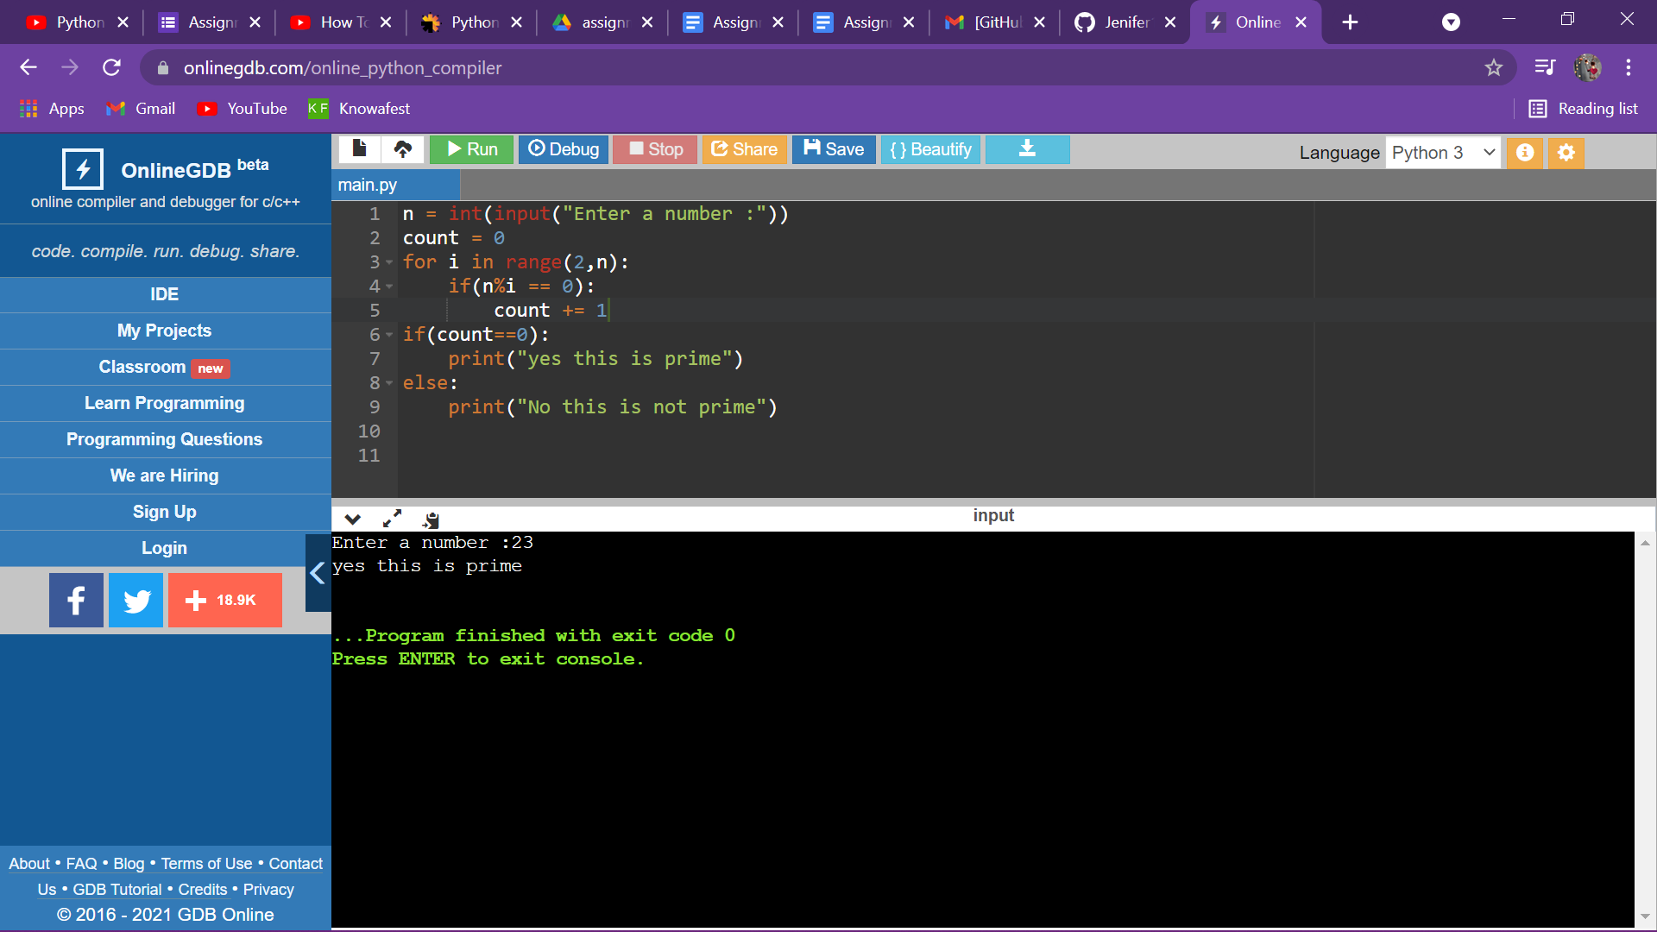

**<https://onlinegdb.com/5En58qWu3>**